Platform—Internal Developer Platform

Bridge between Dev and Ops

Automation team—Product team

E2E(End2End) Lifecycle

Product Team—Developer—Tester—Operations(DevOps)

>> 3 Types of companies

* Service based hike 30%
* Captive based eg Vodafone hike 30-60%
* Product based eg Atlassian hike 100-150%

>> 3 yrs experience valuation. 18 months of product team and 18 months of automation team. 5 points for CV each.

>>

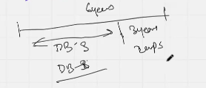

>>

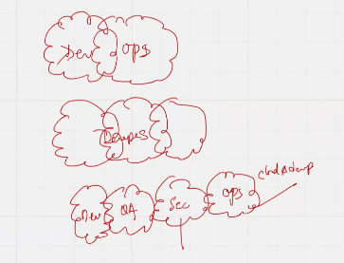

DevOps timeline when it started with Dev+Ops then Dev+tester+ops to Dev+qa+security+ops

>> Difference and comparison – Teams working in SILOS

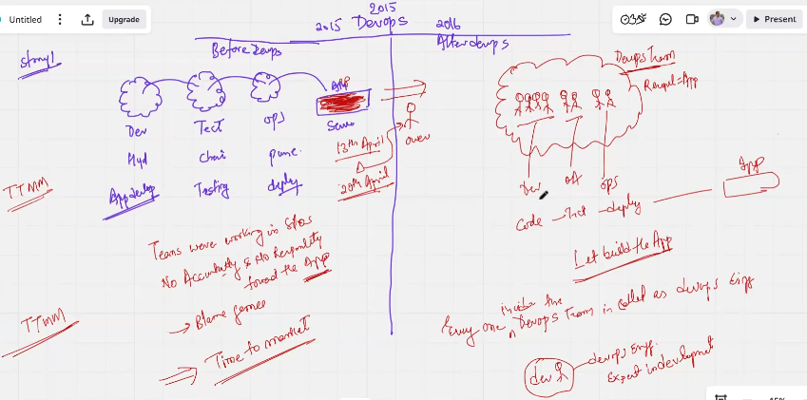

>> On this page we will understand how software developers are differentiated from infra guys

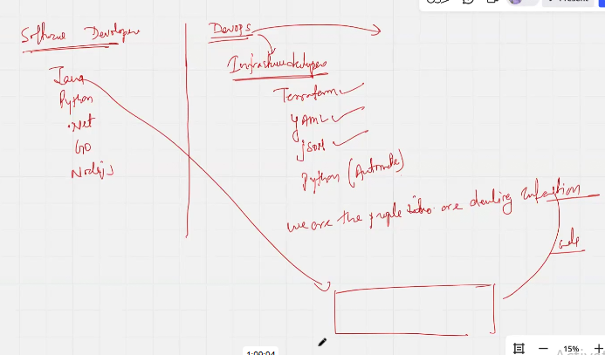

>> Difference and comparison – The blame game

Due to manual changes the dev server and Pre-prod server will drift from the baseline causing loss of configs at launch. Only solution to this identical servers’ problem losing identity overtime is overcome from Automation.

